Classics over Sands

Emergency Plan

CONTENTS
Section
Page No.
1. INTRODUCTION 2
1.1. Event Details 2
1.2. Emergency Response Plan 2
1.3. Risk Factors/ Potential Hazards 2
1.4. Document History 2
2. KEY LOCATIONS 3
2.1. Event Control 3
2.2. First-Aid Point 3
2.3. Lost Children Area 3
2.4. Fire Point 3
2.5. Access/Egress Points 3
3. EMERGENCY RESPONSE PROCEDURES 3
3.1. Identifying Incidents 3
3.2. Communications 3
3.3. Medical Emergency 4
3.4. Fire 4
3.5. Bomb Threats 5
3.6. Emergency Alerting and Evacuation 5
4. ROLES & RESPONSIBILITIES 6
4.1. Event Organiser 6
4.2. Event Safety Co-ordinator 6
4.3. Senior Marshal 7
4.4. Senior Steward 7
4.5. First Aid Providers 7
Appendix A Event Contacts List 8
Appendix B Event Location Map 8
Appendix C Message Scripts 9
Appendix D Distribution List 10

INTRODUCTION

Event Details

Event: Classics over Sands
Date: Sunday 10 August 2025
Timings: Organisers attending from 0900 until 1800 hours Event commences 1100 until 1630 hours. Traffic signage arranged two days prior to event.
Venue: The Memorial Playing Fields, Yew Tree Road, Grange over Sands, LA11 7AA
Audience: 2500 over the day max 750 at any one time (including exhibitors)
Description: A static, display only, classic car & bike show.

Emergency Response Plan

This plan is designed to ensure that the safety of those attending is maintained at all times. Roles, responsibilities, and procedures are defined to ensure a coordinated response to any minor emergencies or major incidents resulting from both on and off-site hazards.

Risk Factors/ Potential Hazards

The playing fields are fenced off with light plastic barriers to prevent uncontrolled access, while allowing relatively easy removal should this be needed.
So far as is reasonable, vehicles and pedestrians are segregated.
While the show is in progress vehicle owners are required to seek the permission of a marshal before moving their vehicle.
Stallholders are required to complete a safety checklist and take appropriate actions to minimise risks.
The main risks have been assessed as those contained in the Safety, Health and Environment (SHE) Policy dated May 2018. Attached Document

Document History
Originally created by Bill Byford based upon a proforma by Claire Storey using guidance from the HSE Event Safety Guide (1999).

Version | Revised | Name
5 | 2025 | Martin Rhodes

KEY LOCATIONS

Event Control
- Situated at the sports pavilion at top of the playing field and accessible from main gate which is controlled by stewards on Yew Tree road.
- All safety documentation and a copy of this plan will be held at Event Control.
- Nominated representatives will attend Event Control, their role is to monitor the event and to record all incidents. The nominated representatives are identified in Appendix 3.
- During the event all communications must be routed through Event Control.

First-Aid Point

St John’s Ambulance and Event Support Team cover 1100 hours to 1630 hours

Lost Children Area
Inside the Event Control Point at playing field pavilion, staffed by female stewards.

Fire Point
Outside the Event Control Point at playing field pavilion.

Access/Egress Points
Gate 1 Pedestrians and vehicular access/egress from Yew Tree Road.
Gate 2 Pedestrians and public vehicular access/egress from Cart Lane.
Gate 3 Pedestrian only access/egress from the Promenade.

EMERGENCY RESPONSE PROCEDURES

Identifying Incidents
In the event of an emergency, the following identification and communication procedures will occur:
- Clearly identifiable stewards, posted at key locations will immediately report incidents or risks to Event Control
- Incident reports by members of the public will be routed via Stewards to Event Control.
- When notifying Event Control of an emergency situation, state the exact location in which the incident has occurred.
- On receipt of a notification, Event Control will be responsible for any necessary response
- All notifications / significant incidents and subsequent actions will be recorded in an event log.

Communications

Event Control Communications
Each individual identified in this plan will carry a mobile phone.
Communications to be tested before event start time.
Contact numbers are contained in Appendix A Event Contacts List.

Communication to the Public - Main PA System
A Public Address System capable of reaching all areas of the show field will be provided.

Medical Emergency
In the event of a medical emergency within the event, the following actions will occur:
- Event Control will be advised of the location and nature of the emergency and will deploy first aiders with steward support as necessary to secure rapid access to the incident location.
- On assessment of the situation, the first aiders will immediately contact Event Control with an update concerning the incident.
- Stewards coordinated through Event Control will secure as necessary clear routes for ambulance access and egress to the requirements of the First Aid Provider.
- Event Control will under advisement from the First Aid Provider:
- Evaluate the information being received.
- If necessary, contact the North West Ambulance Service NHS Trust on 999, to notify them of the situation, and request assistance normally via the Yew Tree Road entrance.
- Advise the relevant agencies, and provide regular updates on the situation.
- Deploy stewards as required.

Fire
Event Control must contact Cumbria Fire and Rescue Service immediately. Call 999 stating the exact location of the fire.
The Stewards deployed in that area, having notified Event Control, will immediately commence evacuation of the immediate area affected by the fire.
The Fire Point contains a selection of hand extinguishing equipment.
Event Control will:
- Identify the extent of the area to be evacuated.
- Identify routes by which evacuation should take place.
- Identify approach routes to the incident for all emergency services.
- Assign Stewards to manage the evacuation and/or move vehicles to create a ‘fire break’ if necessary.

Terrorist Threat
The Event Manager will be responsible for assessing any threat received and the deciding on an appropriate response. If in any doubt a precautionary response should be taken, Police alerted and their advice sought regarding evacuation.

Emergency Alerting and Evacuation
In the event of a major incident occurring, it may be necessary to alert staff of dangers and/or to evacuate the whole show field.
The process of emergency evacuation carries its own risks, and must therefore only be undertaken when absolutely necessary.
The decision to evacuate the event will be made on the basis of an evaluation of the circumstances by Event Control.

Emergency Evacuation Procedure
Wherever possible the Stewards and Marshals must be informed in advance of any broadcast announcement. This will enable them to advise and direct the public from a position of foreknowledge.
- Any music currently playing to cease.
- The designated emergency and back-up microphones to be available and "live".
- STEWARDS to control the Emergency Vehicle access and egress points:
- Event Control to make announcements as required (Appendix C).
- Repeat messages periodically.
- All staff to assist in clearance of the area, in as orderly a manner as possible.
- The primary emergency vehicles access/ egress route has been designated as Gate 1. Further emergency access/egress is available through Gate 2, subject to incident circumstances.
- Marshals, stewards/event personnel will ensure the designated emergency route is cleared of pedestrian traffic as soon as possible so as not to impede the approach, or departure, of the emergency services.
- Special consideration must be given to the evacuation of persons with disabilities.
- Stewards should concentrate on keeping the main body or group of evacuees moving in the correct direction.
- Do not allow people to run - keep contact - avoid panic.
- Not all evacuees will respond to steward’s instructions. Some will be reluctant for ill-advised commercial reasons or emotional motivations. Undue time must not to be spent persuading uncooperative individuals. A secondary sweep will be required through safe locations to engage and remove reluctant individuals.
- All stewards must be observant for signs of evacuees experiencing difficulty through age or infirmity. Young persons separated from adults may show signs of distress. Where possible impart information and reassurance to affected persons.

ROLES & RESPONSIBILITIES

Event Organiser
The Classics over Sands show Committee is responsible for taking such steps as are deemed appropriate and reasonable to ensure the safety of all staff and public attending the event. The Event Organiser is nominated to carry out the role of Main Coordinator through the period of the event on behalf of the Committee.
The Event Organiser will ensure that he, or a competent deputy, is present at all times in Event Control during the event.
The role and responsibilities of the Event Organiser/ Main Controller is as follows:
- Overall responsibility for the Classics over Sands Show.
- Makes resources available if an incident occurs.
- Authority to terminate the event if deemed appropriate in the interests of safety.
- Manages Marshals, Stewards and Officials
- Ensures that an incident log is maintained to record messages and actions taken.

Event Safety Co-ordinator
The role and responsibilities of the Event Safety Coordinator are:
- Overall responsibility for all safety and technical aspects of the event.
- Has the authority, after consultation with the Event Organiser, to terminate the event at any stage, if he deems it appropriate in the interests of public safety.
- Ensures that stewards and officials are effectively performing their roles in respect of crowd management and safety procedures.
- Provision of Health & Safety Advice to Event Control.

Senior Marshal
Responsible for a team of Marshals who’s duties are to regulate vehicle movements within the show field and in the event of an incident to assist and or control members of the public.
The Senior Marshal will:
- Alert Event Control of any incident.
- Manage the scene of the incident until the Emergency Services arrive.
- Provide information on the incident to the Emergency Services and Event Control.
- Help evacuate the public from the event in a safe and orderly manner.
- Aid the Emergency Services as required.
- Manage safe access from the designated emergency gate to the scene of the incident and back to the gate after collecting casualties.

Senior Steward
Responsible for a team of Stewards who’s duties are to regulate vehicle movements within the public car park area and in the event of an incident to assist and or control members of the public.
The Senior Steward will:
- Alert Event Control of any incident.
- Manage the scene of the incident until the Emergency Services arrive.
- Provide information on the incident to the Emergency Services and Event Control.
- Help evacuate the public from the event in a safe and orderly manner.
- Aid the Emergency Services as required.
- Manage safe access from the designated emergency gate to the scene of the incident and back to the gate after collecting casualties.

First Aid Providers
St John’s Ambulance and Event Support Team responsibilities are:
- To provide first aid to attendees of the event.
- Inform Event Control of any serious condition.
- Support for NWAS and other health organisations as required.
- Prior to the commencement of the event:
- A pre-event briefing for all medical staff is held
- First aid post is set up and fully equipped.
- A communication check is carried out within the event area.
- Access and egress points from the medical facilities are clear and maintained, Event Control to be informed of any difficulties.

Appendix A Event Contacts List

NAME | FUNCTION | CONTACT NO.
PAVILION | EVENT CONTROL | 07740 778446
Derek Seward | EVENT CHAIRMAN | 07711 252983
Martin Rhodes | EVENT SAFETY COORDINATOR | 07775 030823
Dave Petty | SENIOR MARSHAL | 07759 484313
Martin Rhodes | SENIOR STEWARD | 07775 030823
TBC | FIRE OFFICER | 07795 063179
Geoff Critchley | Committee Member
Geoff Purnell | Committee Member | 07774 666025
Vince Carter | Committee Member | 07841 85331
Katharina Frey | SAFEGUARDING OFFICER
Phil Kershaw | Committee Member
Lesley Kershaw | Committee Member
Roger Harrison | Committee Member
Police, Fire, Ambulance |  | 999
John Coles | SITE SAFETY AUDIT | 015395 32126
Chris Eckersley | Committee Member
Jon Trevorrow | Committee Member | 07718 231317
Avril Trevorrow | Committee Member | 07718 231317
John Lamb | Committee Member | 07784737752

Appendix B Event Location Map

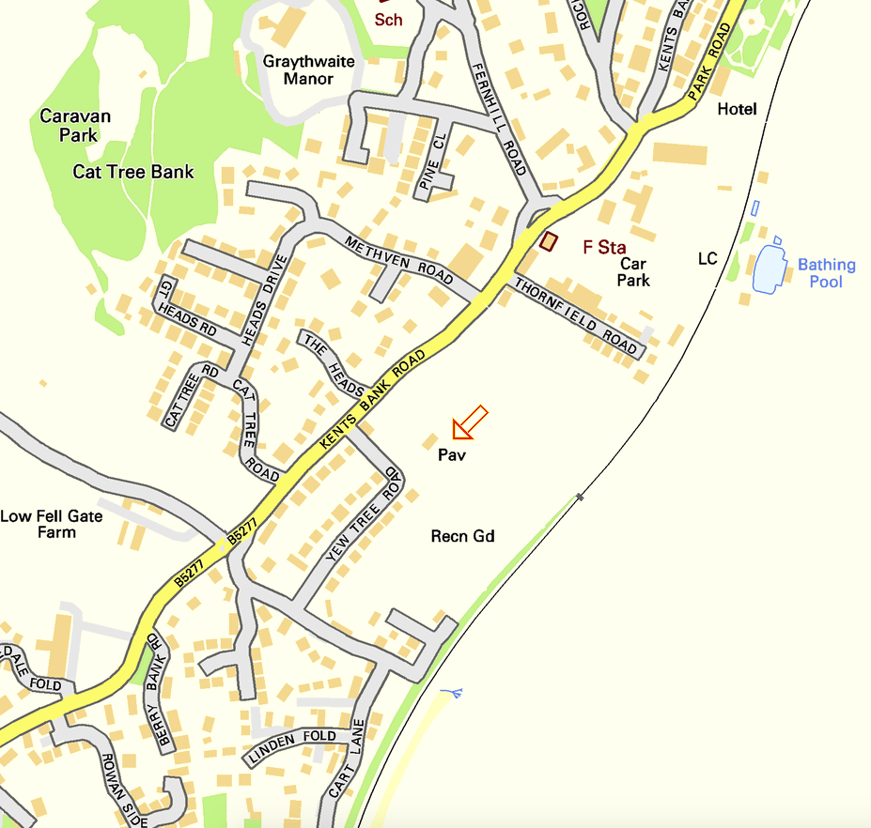
EVENT CONTROL

Appendix C Message Scripts

SUSPECT PACKAGE ( By Telephone)

“Event Control, this is - xxxxxxx - be advised, I have found a suspect package 50 metres south of the tennis court. I repeat - I have found a suspect package 50 metres south of the tennis court. Please Advise”

SITE EVACUATION MESSAGE

ATTENTION PLEASE …. THIS IS AN EMERGENCY MESSAGE.

PLEASE REMAIN CALM

IN THE INTEREST OF PUBLIC SAFETY PLEASE LEAVE THE FIELD BY WALKING TO THE NEAREST EXIT.

POLICE OFFICERS OR STEWARDS WILL DIRECT YOU.

ALL VEHICLES MUST REMAIN ON THE FIELD.

DO NOT RETURN TO YOUR VEHICLE AT THIS TIME.

THANK YOU FOR YOUR CO-OPERATION.

STOPPING THE EVENT (or Cancellation)

LADIES & GENTLEMEN, WE REGRET TO SAY THAT, DUE TO………………….,

THE EVENT HAS NOW BEEN STOPPED / CANCELLED.

IN THE INTERESTS OF SAFETY, CAN YOU PLEASE MAKE YOUR WAY SAFELY TOWARDS THE EXITS.

WOULD VEHICLE OWNERS ONLY MOVE THEIR VEHICLE WHEN IT IS SAFE TO DO SO

THANK YOU FOR YOUR PATIENCE

Appendix D Distribution List
Recipient | Organisation | Copy No.
Derek Seward | Event Control | 1
Martin Rhodes | Event Safety Coordinator | 2
Dave Petty | Senior Marshal | 3
Martin Rhodes | Senior Steward | 4
John Coles | Safety Auditor | 5
 | St. John’s Ambulance Service - First Aid Providers | 6

